
RMNSUG
NetSuite Saved Searches
Tips & Tricks
November 11, 2020

Prepared by:
Rick Cobb
NetSuite Administrator / Solution Architect
Blytheco
949.583.9500 x1341
303.589.8598 Cell
rcobb@blytheco.com

Table of Contents
Case Statements to Segment Results Into Separate Columns Formula (Numeric) 3
Create Clickable Links via Formula(Text) 4
Saved Searches with Text Formatting in Columns 6
Saved Searches with Conditional Highlighting in Columns 7
Progress Bar in Saved Search Results Column 8
Colored Dots To Reflect Status as Saved Search Results Column 10
Saved Search Aggregate Functions to Show Details in Summarized Search 11
Saved Search with Revenue, Cost, and Profit 12
Saved Search with SQL Formulas to Calculate Percentage of Total 14
Customer Ledger with Running Balance Total 16
Filtering Field Choices Based on Selection in Another Field 19
Custom records in tab on customer screen 20
Display Item Numbers AND Display Names 22
Turn on Knowledge Base 22
Mass Delete Script 23
SQL Expressions and SuiteScript 1.0 Search Operators 35
Search Items by Number and Description on SO Lines 36
UPS Integration Configuration 37

Case Statements to Place Results Into Separate Columns Formula (Numeric)

The CASE statement is a type if IF-THEN-ELSE statement that can be used by any of the formula types; this example is Formula (Numeric).
The CASE statement has a couple of different formats:
CASE WHEN condition1 is true THEN results1
WHEN condition2 is true THEN results2
…
ELSE default END

CASE field
WHEN value1 THEN results1
WHEN value2 THEN results2
…
ELSE default END

That logic can be used to create separate columns in a summarized saved search based on item type (for example):
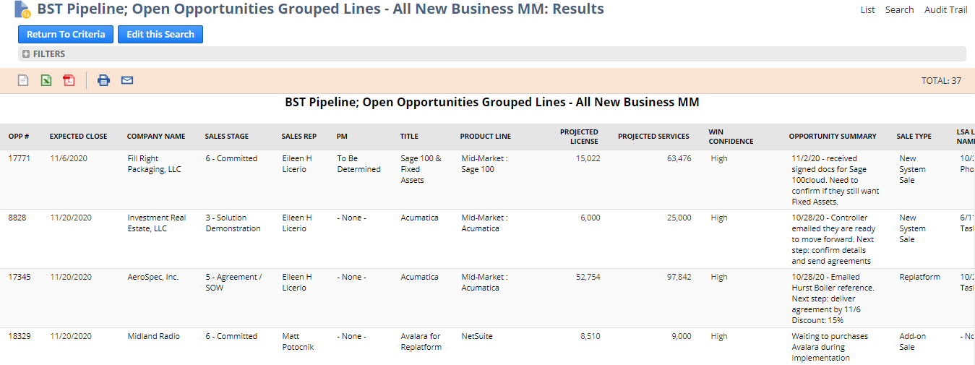

Create Clickable Links via Formula(Text)

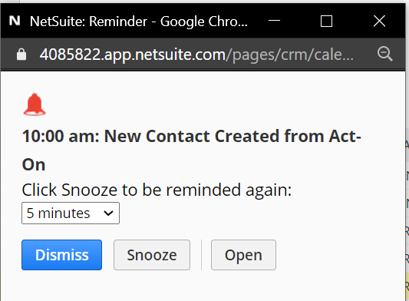

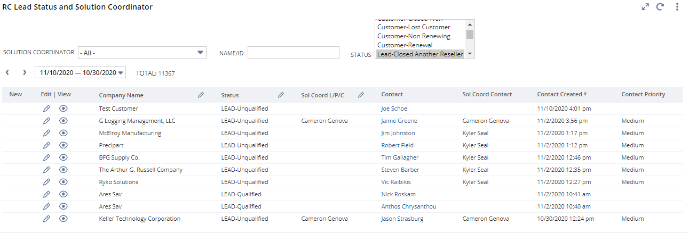

This leverages the HTML href attribute functionality:
https://www.w3schools.com/tags/att_a_href.asp
<a href=”https://www.blytheco.com”>Click Here</a> Web address + clickable link
To display the contact, look at the contact screen URL:
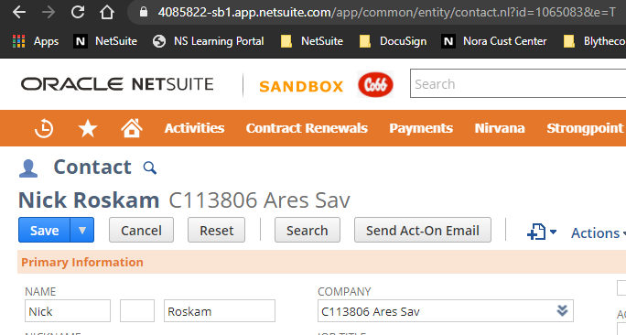
Assumed
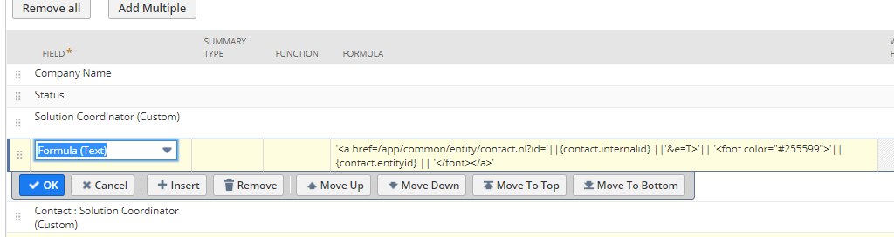
'<a href=/app/common/entity/contact.nl?id='||{contact.internalid} ||'&e=T>'|| '<font color="#255599">'|| {contact.entityid} || '</font></a>'

'<a href=/app/common/entity/contact.nl?id=' Set up the href tag with the
||{contact.internalid} Use the contact internal ID
||'&e=T>' Bring up the contact in Edit mode
|| '<font color="#255599">' Make the following text blue (like a hyperlink)
|| {contact.entityid} Use the contact name
|| '</font></a>' Close the href attribute

Saved Searches with Text Formatting in Columns
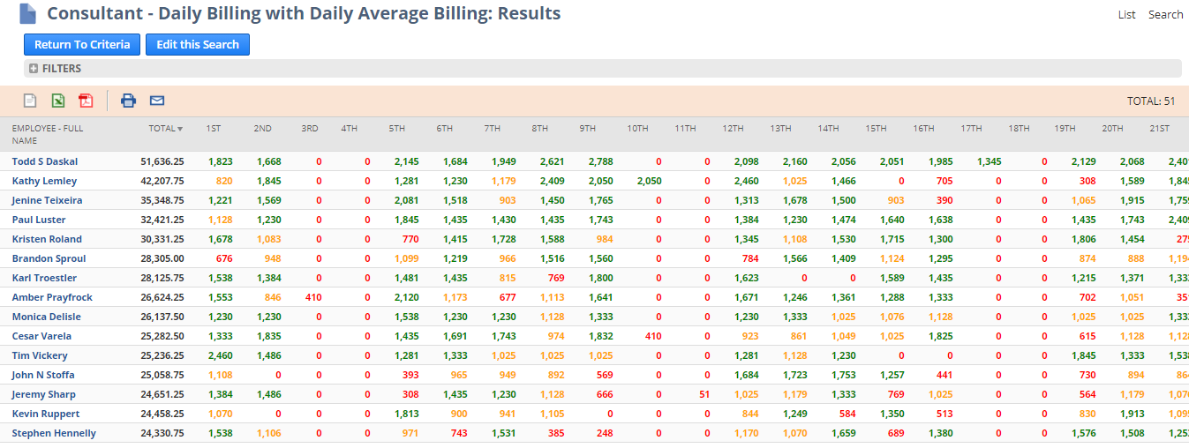
Colors represent achievement of daily billable targets per consultant per day in dollars:
$1200 or above $800-$1199 Below $800
CASE statements are used to both apply text color formats as well place the daily billings in the appropriate columns (1st to 31st days of the month):
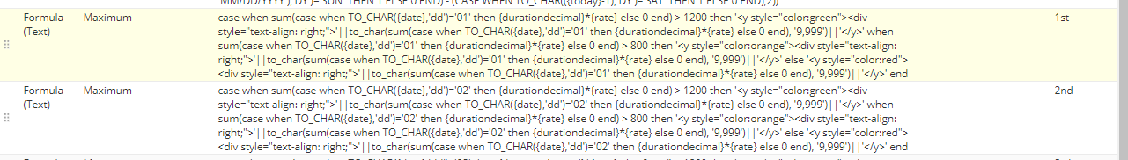
case when sum(case when TO_CHAR({date},'dd')='01' then {durationdecimal}*{rate} else 0 end) > 1200
then '<y style="color:green"><div style="text-align: right;">'||to_char(sum(case when TO_CHAR({date},'dd')='01' then {durationdecimal}*{rate} else 0 end), '9,999')||'</y>'
when sum(case when TO_CHAR({date},'dd')='01' then {durationdecimal}*{rate} else 0 end) > 800
then '<y style="color:orange"><div style="text-align: right;">'||to_char(sum(case when TO_CHAR({date},'dd')='01' then {durationdecimal}*{rate} else 0 end), '9,999')||'</y>'
else '<y style="color:red"><div style="text-align: right;">'||to_char(sum(case when TO_CHAR({date},'dd')='01' then {durationdecimal}*{rate} else 0 end), '9,999')||'</y>' end

A few things going on here:
What day of the month does the time entry record fall?
What is the sum of the dollars (durationdecimal * rate) for the day?
What color should we assign the summed result?
Need to convert the number to text to apply the proper color attribute
Right-align the text “number”

Saved Searches with Conditional Highlighting in Columns

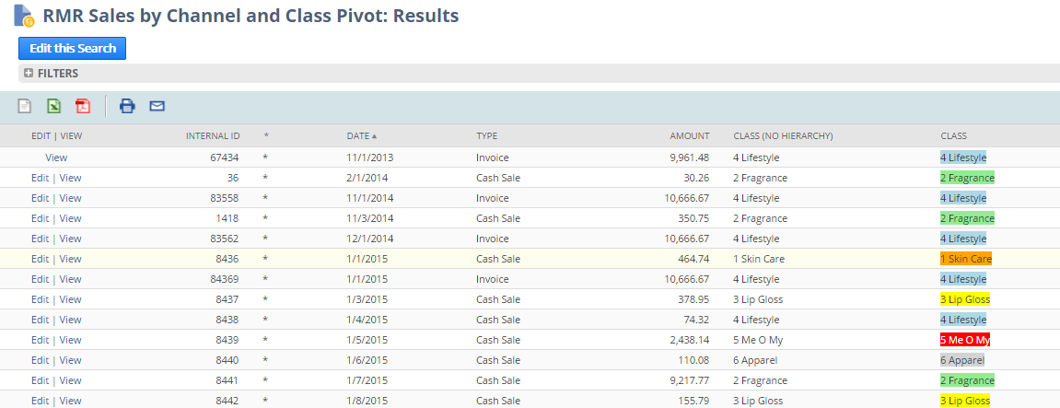

Results:
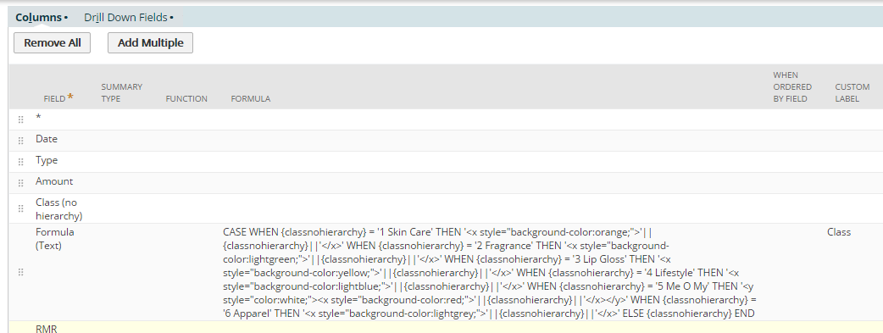

Formula(Text):
CASE
WHEN {classnohierarchy} = '1 Skin Care' THEN '<x style="background-color:orange;">'||{classnohierarchy}||'</x>'
WHEN {classnohierarchy} = '2 Fragrance' THEN '<x style="background-color:lightgreen;">'||{classnohierarchy}||'</x>'
WHEN {classnohierarchy} = '3 Lip Gloss' THEN '<x style="background-color:yellow;">'||{classnohierarchy}||'</x>'
WHEN {classnohierarchy} = '4 Lifestyle' THEN '<x style="background-color:lightblue;">'||{classnohierarchy}||'</x>'
WHEN {classnohierarchy} = '5 Me O My' THEN '<y style=”color:white;”>
<x style="background-color:red;">'||{classnohierarchy}||'</x></y>'
WHEN {classnohierarchy} = '6 Apparel' THEN '<x style="background-color:grey;">'||{classnohierarchy}||'</x>'
ELSE {classnohierarchy}
END

Progress Bar in Saved Search Results Column

Here is an example of a progress bar with different colored progress bars based on conditions:
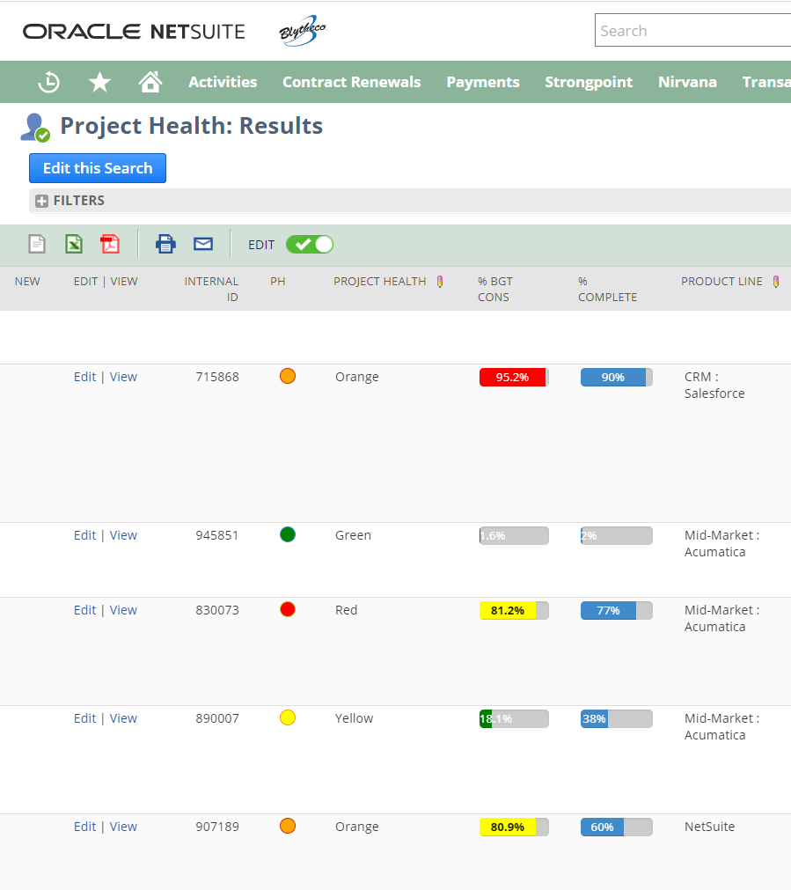
Here’s the formula in the formula(text) column:
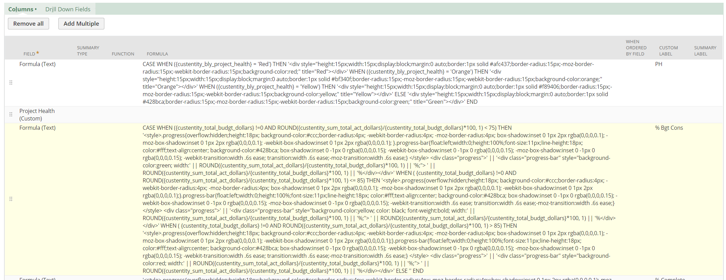

CASE
WHEN ({custentity_total_budgt_dollars} !=0 AND ROUND({custentity_sum_total_act_dollars}/{custentity_total_budgt_dollars}*100, 1) < 75)
THEN '<style>.progress{overflow:hidden;height:18px; background-color:#ccc;border-radius:4px; -webkit-border-radius:4px; -moz-border-radius:4px; box-shadow:inset 0 1px 2px rgba(0,0,0,0.1); -moz-box-shadow:inset 0 1px 2px rgba(0,0,0,0.1); -webkit-box-shadow:inset 0 1px 2px rgba(0,0,0,0.1); }.progress-bar{float:left;width:0;height:100%;font-size:11px;line-height:18px; color:#fff;text-align:center; background-color:#428bca; box-shadow:inset 0 -1px 0 rgba(0,0,0,0.15); -webkit-box-shadow:inset 0 -1px 0 rgba(0,0,0,0.15); -moz-box-shadow:inset 0 -1px 0 rgba(0,0,0,0.15); -webkit-transition:width .6s ease; transition:width .6s ease;-moz-transition:width .6s ease;} </style>
<div class="progress">' || '<div class="progress-bar" style="background-color:green; width:' || ROUND({custentity_sum_total_act_dollars}/{custentity_total_budgt_dollars}*100, 1) || '%;"> ' || ROUND({custentity_sum_total_act_dollars}/{custentity_total_budgt_dollars}*100, 1) || '%</div></div>'
WHEN ( {custentity_total_budgt_dollars} !=0 AND ROUND({custentity_sum_total_act_dollars}/{custentity_total_budgt_dollars}*100, 1) <= 85)
THEN '<style>.progress{overflow:hidden;height:18px; background-color:#ccc;border-radius:4px; -webkit-border-radius:4px; -moz-border-radius:4px; box-shadow:inset 0 1px 2px rgba(0,0,0,0.1); -moz-box-shadow:inset 0 1px 2px rgba(0,0,0,0.1); -webkit-box-shadow:inset 0 1px 2px rgba(0,0,0,0.1);}.progress-bar{float:left;width:0;height:100%;font-size:11px;line-height:18px; color:#fff;text-align:center; background-color:#428bca; box-shadow:inset 0 -1px 0 rgba(0,0,0,0.15); -webkit-box-shadow:inset 0 -1px 0 rgba(0,0,0,0.15); -moz-box-shadow:inset 0 -1px 0 rgba(0,0,0,0.15); -webkit-transition:width .6s ease; transition:width .6s ease;-moz-transition:width .6s ease;} </style>
<div class="progress">' || '<div class="progress-bar" style="background-color:yellow; color: black; font-weight:bold; width:' || ROUND({custentity_sum_total_act_dollars}/{custentity_total_budgt_dollars}*100, 1) || '%;"> ' || ROUND({custentity_sum_total_act_dollars}/{custentity_total_budgt_dollars}*100, 1) || '%</div></div>' WHEN ( {custentity_total_budgt_dollars} !=0 AND ROUND({custentity_sum_total_act_dollars}/{custentity_total_budgt_dollars}*100, 1) > 85)
THEN '<style>.progress{overflow:hidden;height:18px; background-color:#ccc;border-radius:4px; -webkit-border-radius:4px; -moz-border-radius:4px; box-shadow:inset 0 1px 2px rgba(0,0,0,0.1); -moz-box-shadow:inset 0 1px 2px rgba(0,0,0,0.1); -webkit-box-shadow:inset 0 1px 2px rgba(0,0,0,0.1);}.progress-bar{float:left;width:0;height:100%;font-size:11px;line-height:18px; color:#fff;text-align:center; background-color:#428bca; box-shadow:inset 0 -1px 0 rgba(0,0,0,0.15); -webkit-box-shadow:inset 0 -1px 0 rgba(0,0,0,0.15); -moz-box-shadow:inset 0 -1px 0 rgba(0,0,0,0.15); -webkit-transition:width .6s ease; transition:width .6s ease;-moz-transition:width .6s ease;} </style>
<div class="progress">' || '<div class="progress-bar" style="background-color:red; width:' || ROUND({custentity_sum_total_act_dollars}/{custentity_total_budgt_dollars}*100, 1) || '%;"> ' || ROUND({custentity_sum_total_act_dollars}/{custentity_total_budgt_dollars}*100, 1) || '%</div></div>'
ELSE '' END

% Complete - No Colors

'<style>.progress{overflow:hidden;height:18px;background-color:#ccc;border-radius:4px;-webkit-border-radius:4px;-moz-border-radius:4px;box-shadow:inset 0 1px 2px rgba(0,0,0,0.1);-moz-box-shadow:inset 0 1px 2px rgba(0,0,0,0.1);-webkit-box-shadow:inset 0 1px 2px rgba(0,0,0,0.1);}.progress-bar{float:left;width:0;height:100%;font-size:11px;line-height:18px;color:#fff;text-align:center;background-color:#428bca;box-shadow:inset 0 -1px 0 rgba(0,0,0,0.15);-webkit-box-shadow:inset 0 -1px 0 rgba(0,0,0,0.15);-moz-box-shadow:inset 0 -1px 0 rgba(0,0,0,0.15);-webkit-transition:width .6s ease;transition:width .6s ease;-moz-transition:width .6s ease;}</style><div class="progress">' || '<div class="progress-bar" style="width:' || ROUND({custentity_bly_percentworkcomplete}*100, 1) || '%;"> ' || ROUND({custentity_bly_percentworkcomplete}*100, 1) || '%</div></div>'

Colored Dots To Reflect Status as Saved Search Results Column

Here is an example of different colored dots based on conditions:
Here’s the formula in the formula(text) column:
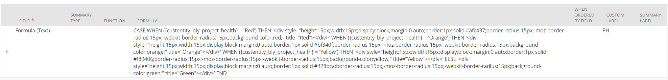
CASE
WHEN ({custentity_bly_project_health} = 'Red')
THEN '<div style="height:15px;width:15px;display:block;margin:0 auto;border:1px solid #afc437;border-radius:15px;-moz-border-radius:15px;-webkit-border-radius:15px;background-color:red;" title="Red"></div>'
WHEN ({custentity_bly_project_health} = 'Orange')
THEN '<div style="height:15px;width:15px;display:block;margin:0 auto;border:1px solid #bf340f;border-radius:15px;-moz-border-radius:15px;-webkit-border-radius:15px;background-color:orange;" title="Orange"></div>' WHEN ({custentity_bly_project_health} = 'Yellow')
THEN '<div style="height:15px;width:15px;display:block;margin:0 auto;border:1px solid #f89406;border-radius:15px;-moz-border-radius:15px;-webkit-border-radius:15px;background-color:yellow;" title="Yellow"></div>' ELSE '<div style="height:15px;width:15px;display:block;margin:0 auto;border:1px solid #428bca;border-radius:15px;-moz-border-radius:15px;-webkit-border-radius:15px;background-color:green;" title="Green"></div>' END

Saved Search Aggregate Functions to Show Details in Summarized Search

Here is an example of the LISTAGG function used to both aggregate detailed results in a saved search, AND report details within the aggregated row.
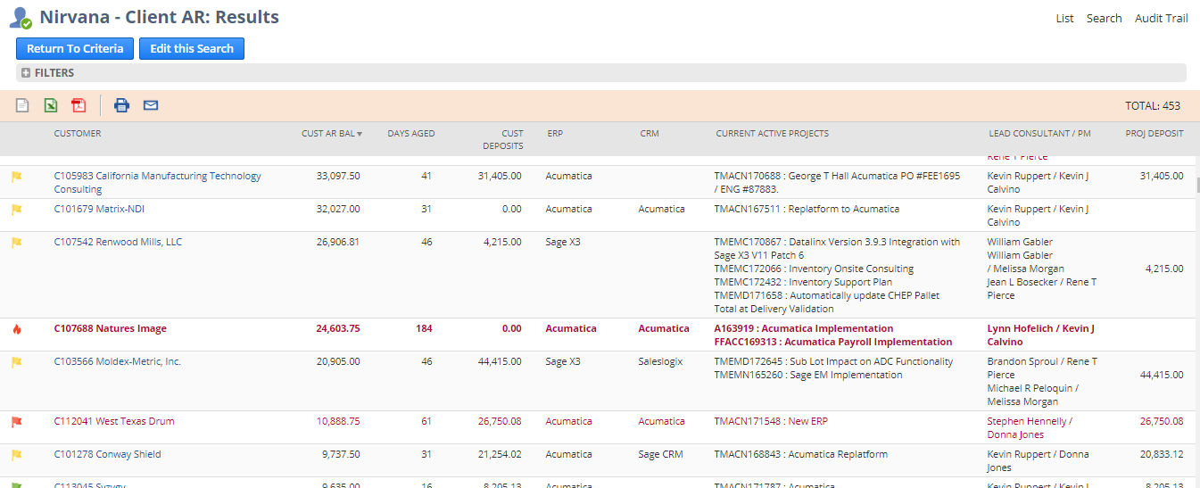
Note the clauses in the LISTAGG expression to order the results :
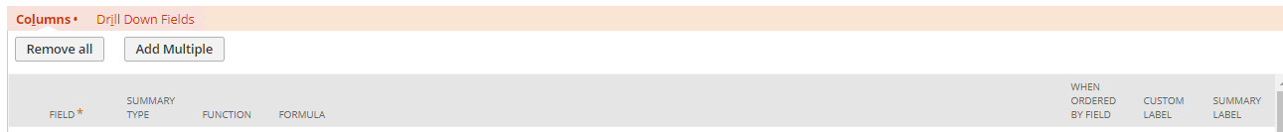
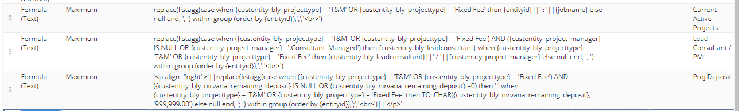

replace(listagg(case when {custentity_bly_projecttype} = 'T&M' OR {custentity_bly_projecttype} = 'Fixed Fee' then {entityid}||' : '||{jobname} else null end, ', ') within group (order by {entityid}),',','<br>')

Saved Search with Revenue, Cost, and Profit

Hi Team!

I had a pretty complex request pop up that sounds easier than it turns out to be. Currently there is an enhancement request out to see revenue, cost and profit on the same report/search. However, it can be accomplished via the following formulas in a saved search. I am giving you screen shots of the criteria and results and then copying the exact formulas below so you could copy and paste them in a search. I have a feeling this is something a lot of clients would want and these formulas use NS standard fields. So you should be able to just copy them. Please let me know if you have questions or need help replicating this for a client.

Mike (and team) – this is the type of info that would make a great knowledge base! ☺

Criteria:

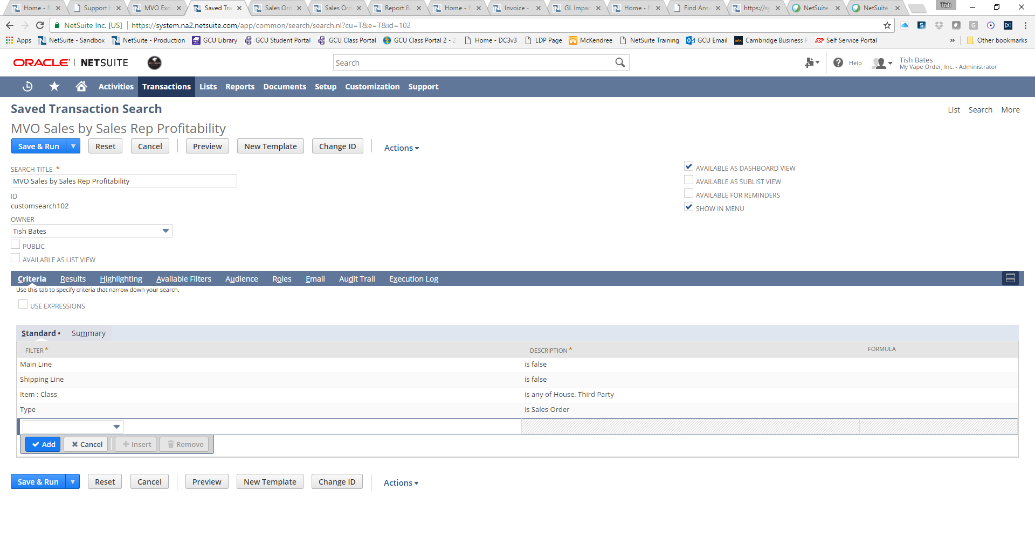

Results – WITH FORMULAS
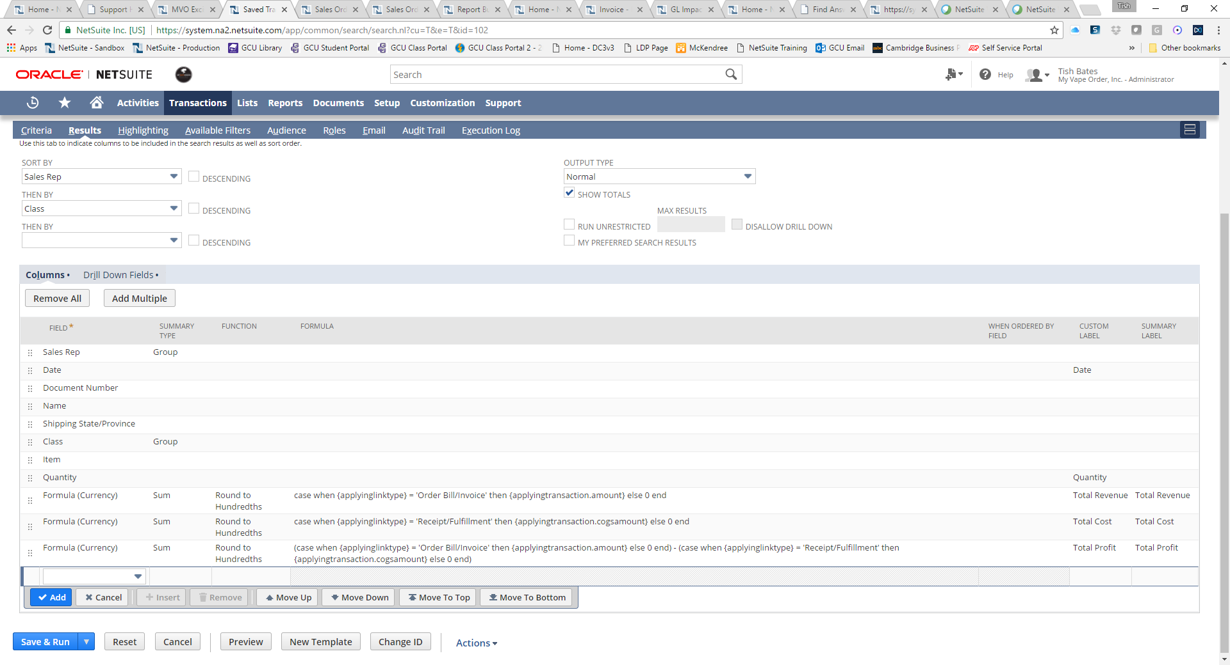
Total Revenue Formula
case when {applyinglinktype} = 'Order Bill/Invoice' then {applyingtransaction.amount} else 0 end

Total Cost of Goods Sold Formula
case when {applyinglinktype} = 'Receipt/Fulfillment' then {applyingtransaction.cogsamount} else 0 end

Total Profit Formula
(case when {applyinglinktype} = 'Order Bill/Invoice' then {applyingtransaction.amount} else 0 end) - (case when {applyinglinktype} = 'Receipt/Fulfillment' then {applyingtransaction.cogsamount} else 0 end)

Again! Hope this helps!

Saved Search with SQL Formulas to Calculate Percentage of Total
This search is able to sum the total number of SO quantity and compare it to a lesser number of total tickets for the same item. The crux here is that the avg(), count(), and sum() functions respect the grouping in the save search:
Nsdemo12@blytheco.com / NetSuite99!
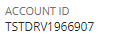
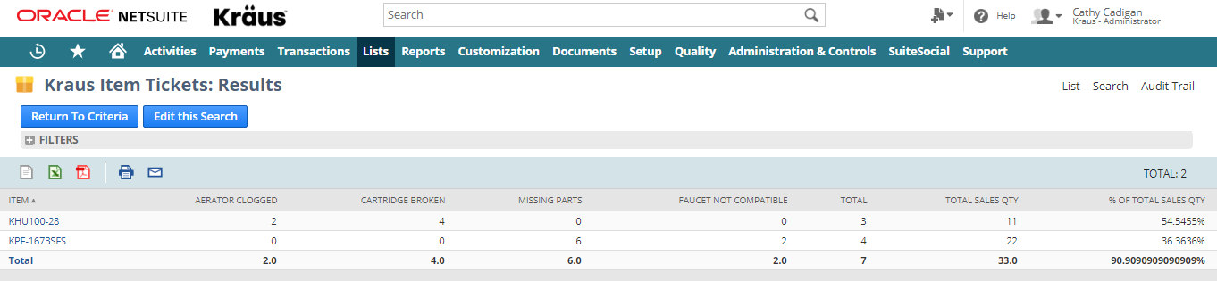
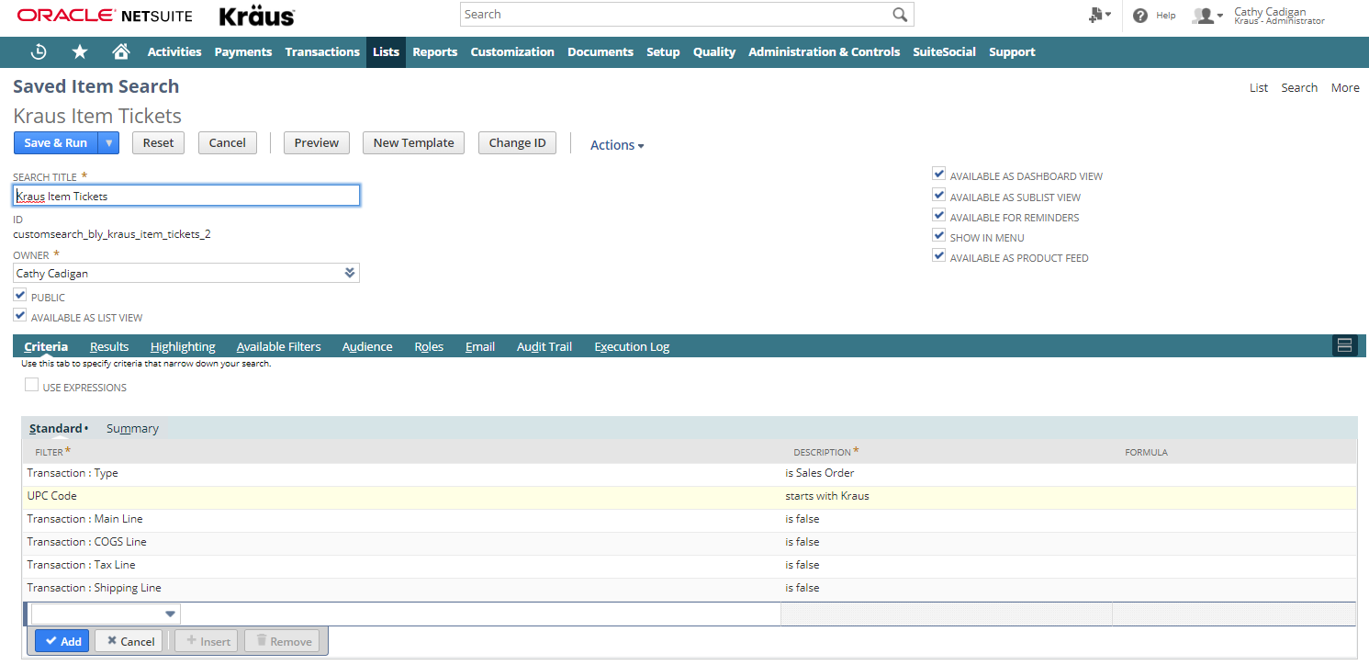
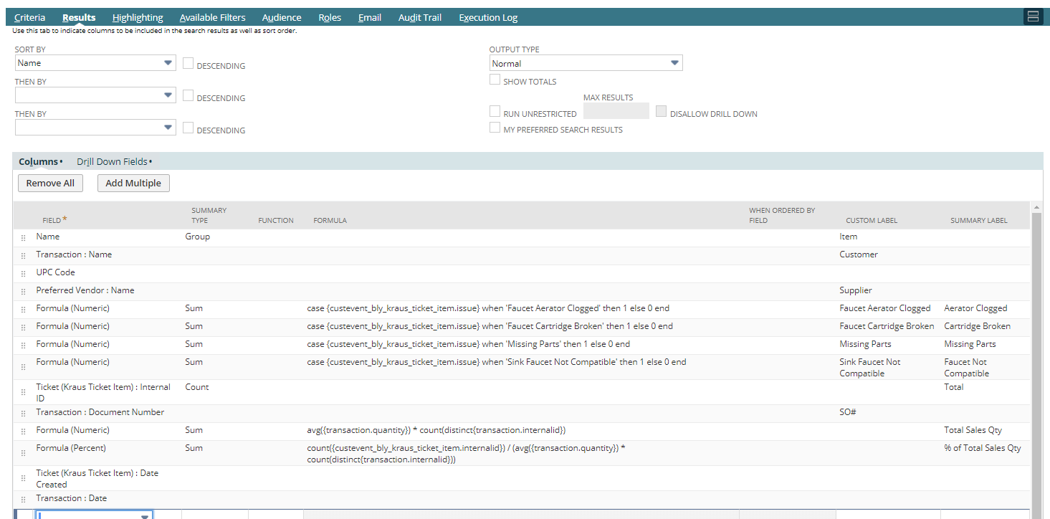

Customer Ledger with Running Balance Total
Tish,

Good stuff! Thanks.

First question: I don’t see any type of running balance column that would show the customer balance after each transaction. Ever done that?
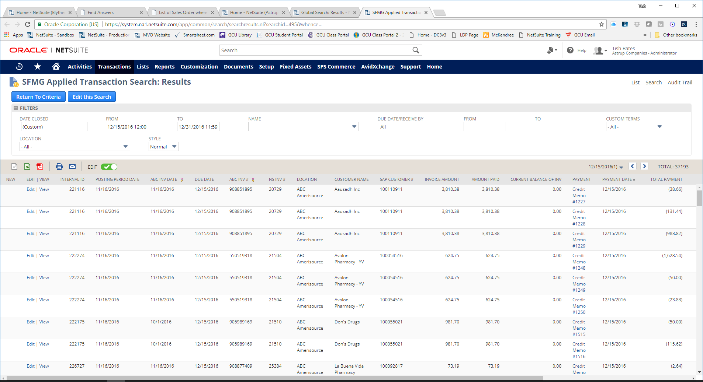

Criteria

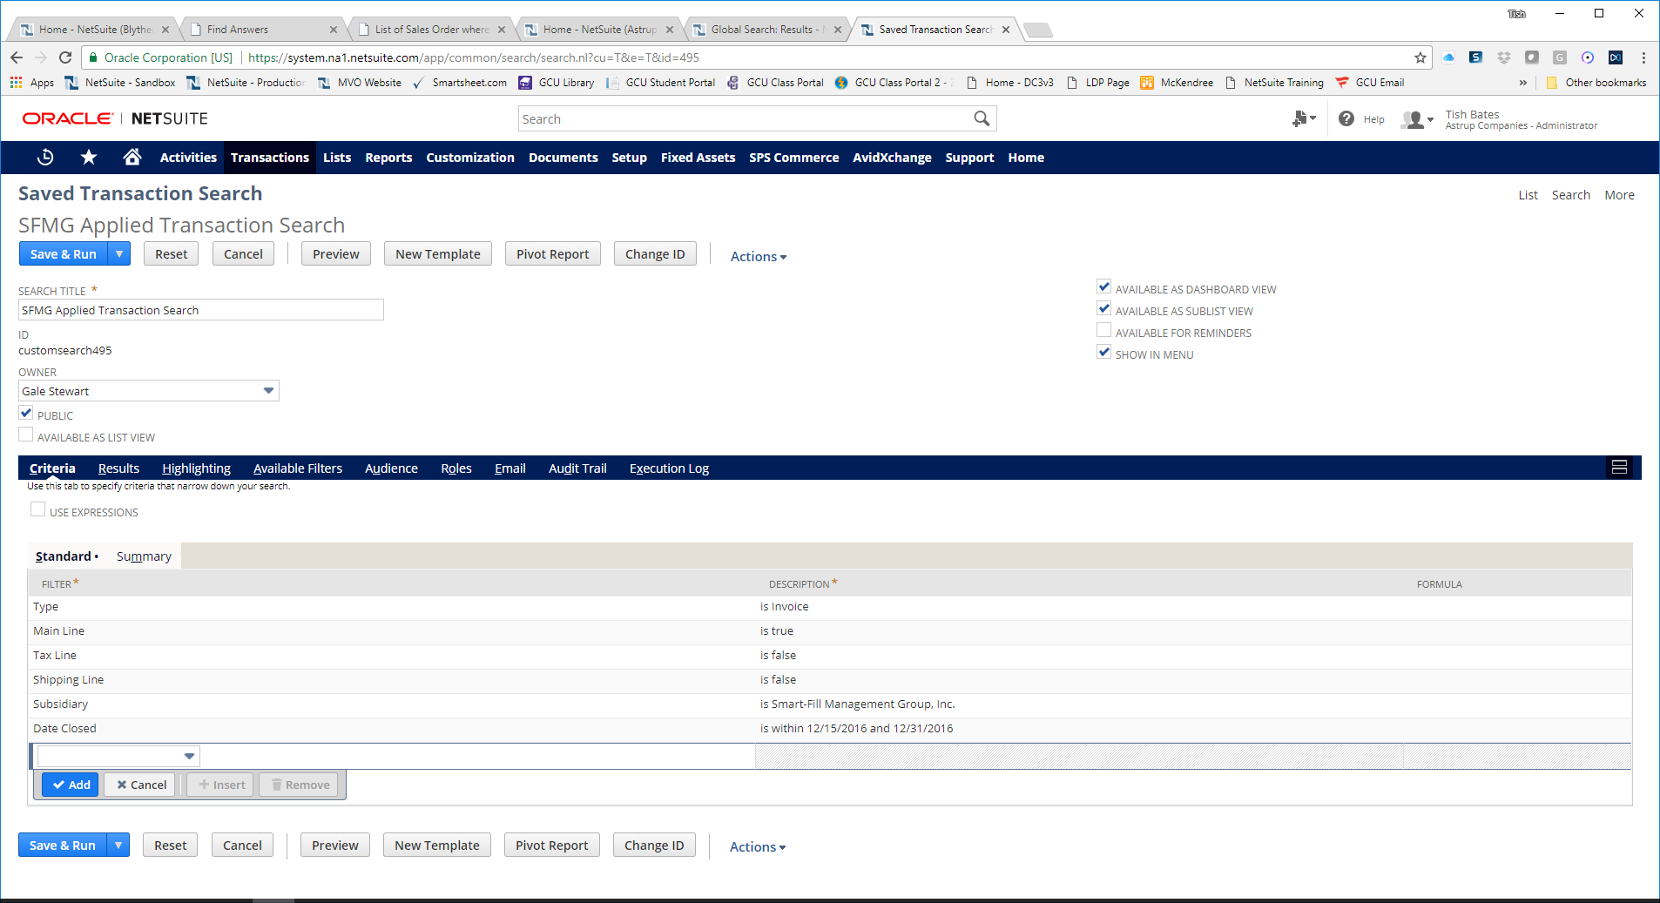

Results

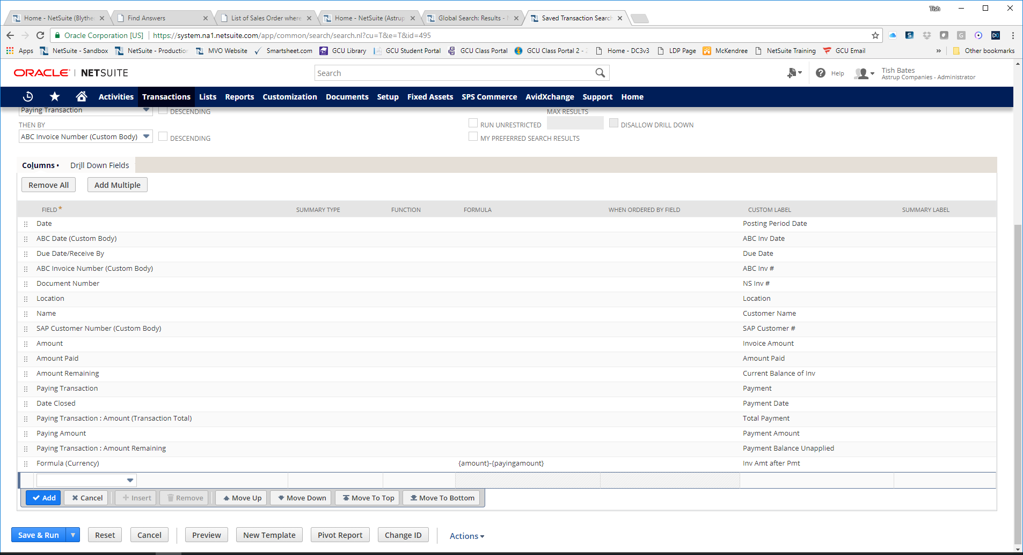

You can also add Created From in here and that will show you the SO associated with this line of transactions. SFMG only uses SO for Warehouse and this one didn’t really require that. Let me know if you need anything else. Thanks!

 | Tish Bates  NetSuite Consultant  Blytheco  Laguna Hills, CA  Office: (949) 583-9500 Ext. 2229  Cell: (618) 558-6276  Email: tbates@blytheco.com

Filtering Field Choices Based on Selection in Another Field

Hi Rick,
Thank you for your time earlier. Below is the summary of our conversation.
Concern:
We wanted to implement a custom list field on the customer record that returns the contacts associated to the customer. However, the field that we've created is either returning every contact record or none.
Assessment:
On the Sourcing & Filtering subtab, Filter Using column is the field on the list record that we want to compare with our current record. By intuition it should be the Company field. However, using this field is not returning the correct results.
As a workaround, we'll use the Parent field instead. Below are the steps that we did in order to update the custom field.
- Navigate to Customization > Lists, Records, & Fields > Entity Fields
- Click on the First Contact custom field
- Navigate to the Sourcing & Filtering subtab
- Set the table with the following values:
Filter Using: Parent
Compare Type: Equal
Value Is: Current Record
- Click Save
As agreed, I will now proceed in closing this case.
Best Regards,

Custom records in tab on customer screen
Create custom tab
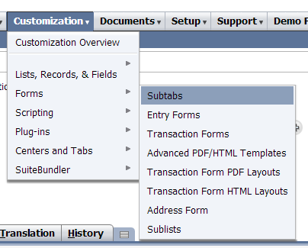
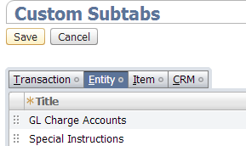

Create custom record
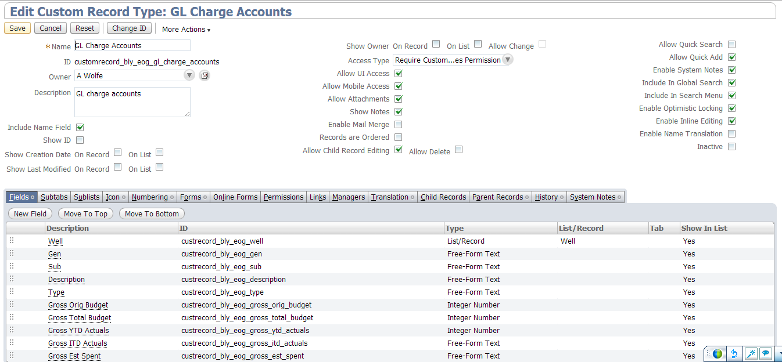

Make common field as type list/record and link to customer, checking the Record is Parent box, as well as Parent Subtab to tab on customer screen (which can be custom) selected:
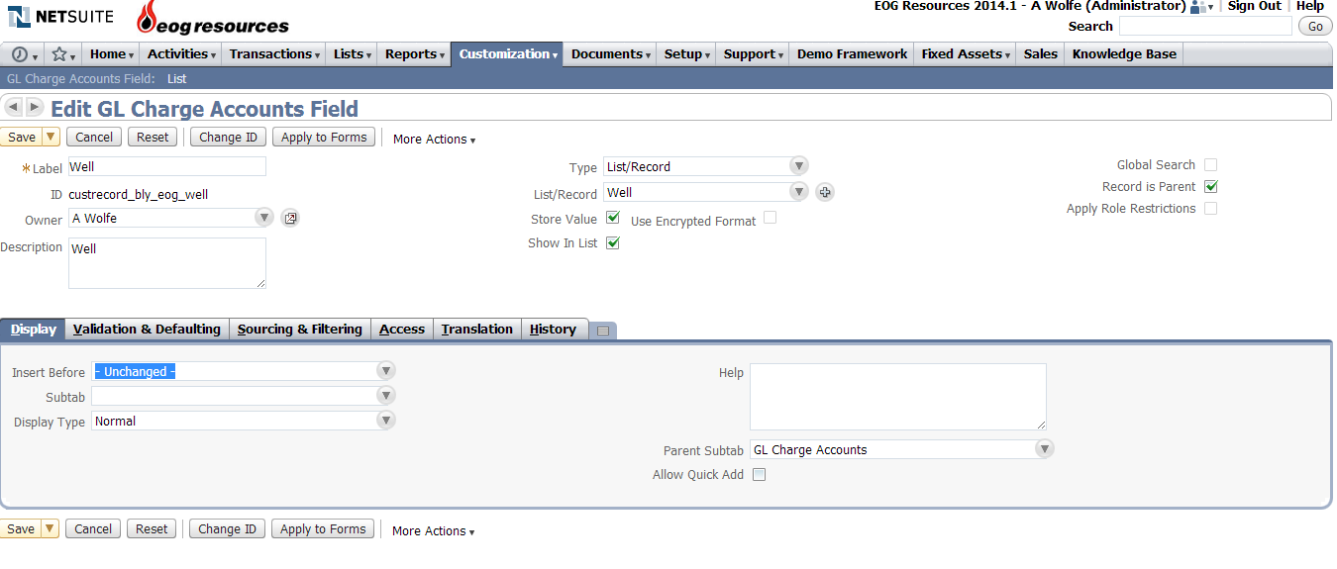

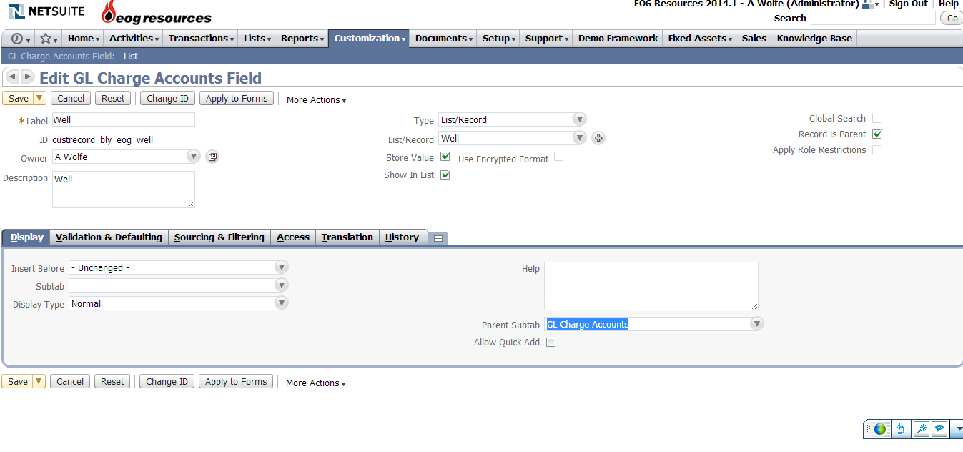

Display Item Numbers AND Display Names
For displaying/searching both item numbers and display names:
1. Go to Setup > Company > General Preferences > Show Display Name with Item Codes = T > Click Save.

2. Go to Home > Set Preferences > Analytics tab > Popup Search Uses Keywords = T > Click Save.

Turn on Knowledge Base
In order for all the topics to show on the Customer Center, you need to edit it and assign on the Audience = Customer Center role.
1. Navigate to: List > Support > Knowledge Base > edit General > Audience = Customer Center.
You can find more information in our SuiteAnswers Article: Publishing a Knowledge Base, Article Id: 11071
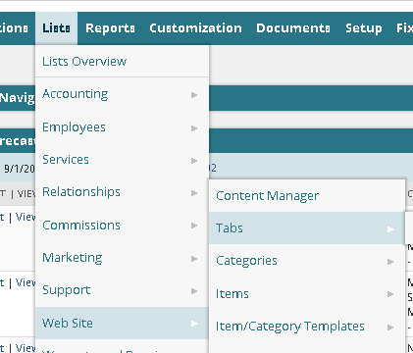
Created new web tab

Mass Delete Script
The script below will delete the records specified in a saved search; it is used by the Mass Update – Delete function to delete every record in the search results.
The first step is to create a mass update script:
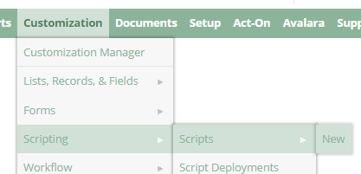

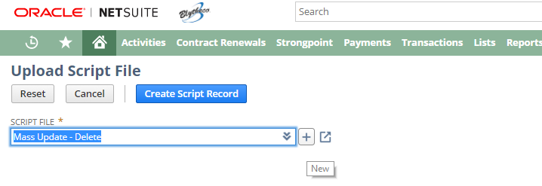
Click the + to select the text file that contains the script file contents:
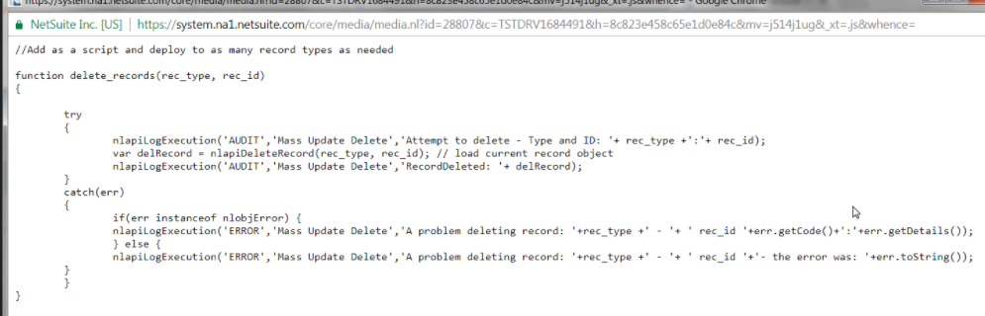

// script to delete all records
// deploy for appropriate record types
// used by mass updates; criteria on mass updates controls what records to delete
// leave script in testing mode so only author can trigger it

function delete_record(rec_type, rec_id)
{
try
{
nlapiLogExecution('AUDIT', 'Mass Update Delete', 'Attempt to delete - type and ID: ' + rec_type + ':' + rec_id);
var delRecord = nlapiDeleteRecord(rec_type, rec_id); // load current record object
nlapiLogExecution('AUDIT', 'Mass Update Delete', 'RecordDeleted: ' + delRecord);
}

catch(err)
{
if(err instanceof nlobjError) {
nlapiLogExecution('ERROR', 'Mass Update Delete', 'A problem deleting record: ' + rec_type + ' - ' + ' rec_id ' + err.getCode() + ':' + err.getDetails());
} else {
nlapiLogExecution('ERROR', 'Mass Update Delete', 'A problem deleting record: ' + rec_type + ' - ' + ' rec_id ' + '- the error was: ' + err.toString());
}
}
}

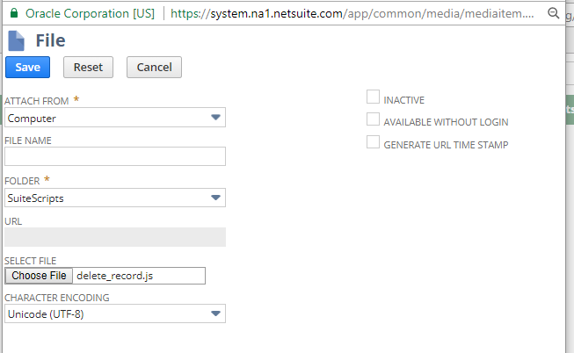

Click Save to see:
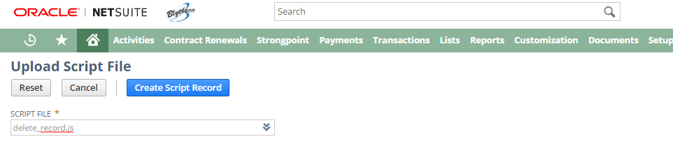

Click Create Script Record to see:

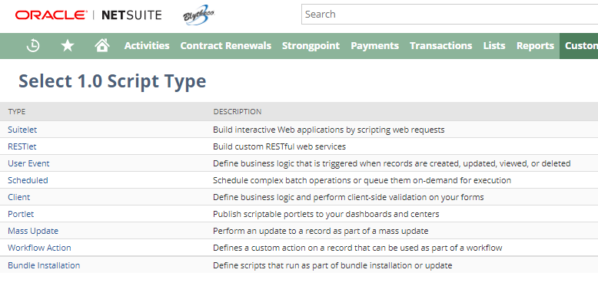
Click Mass Update to see:

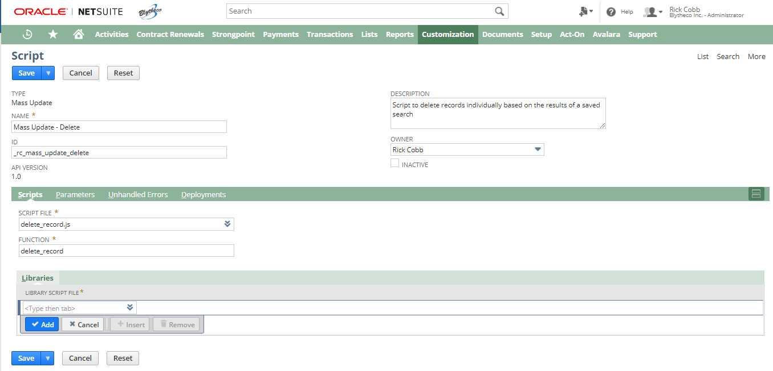
Fill in required information and click Save to see:

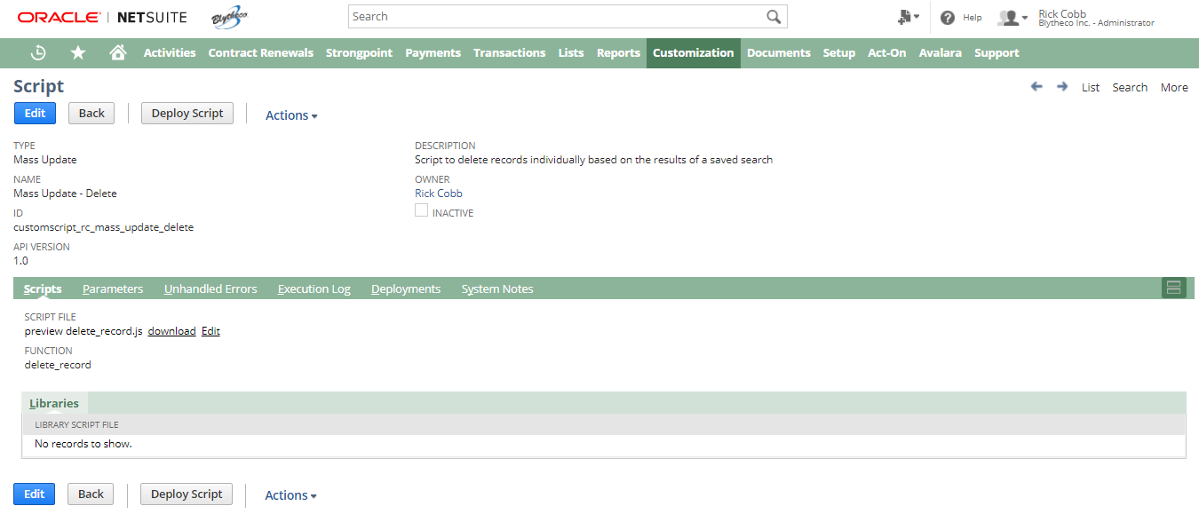
In order to use the script file in a mass update, you’ll click on the Deployments tab to create one or more deployments:
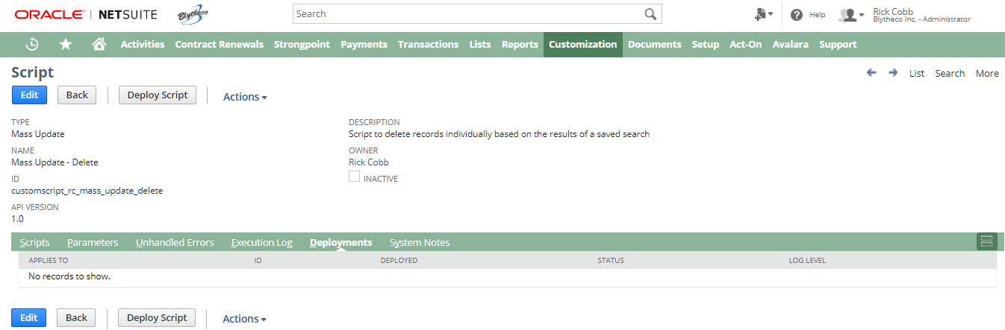
Click Deploy Script to see:
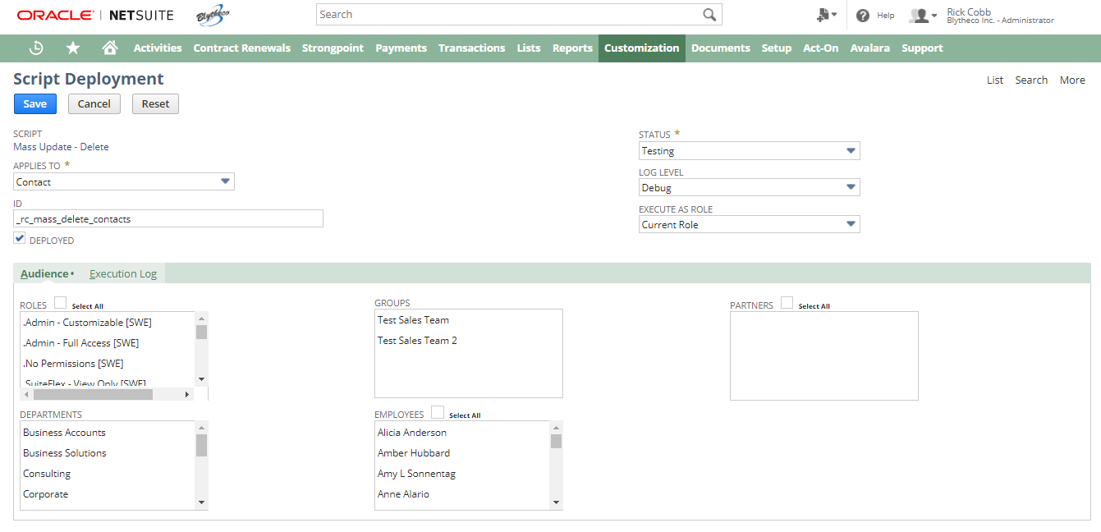
This is where you specify the record type you wish to delete. Also note the Status = Testing; this ensures ONLY the owner of the script can execute it. Click Save to see:
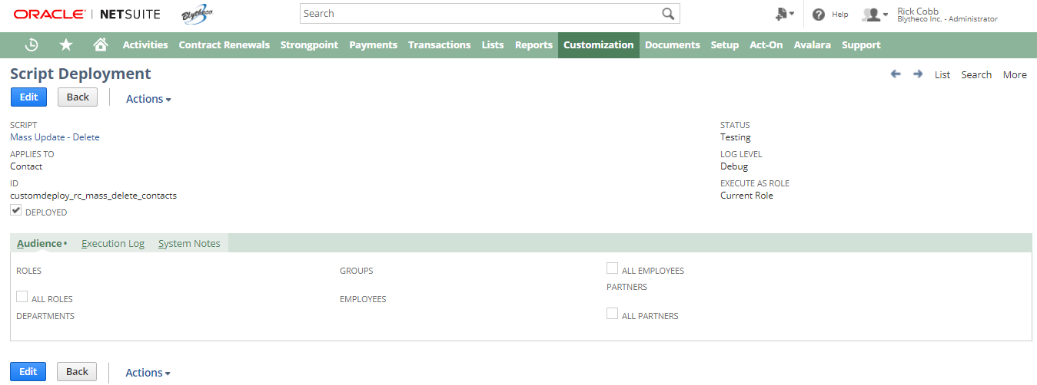
To use the script to mass delete records:
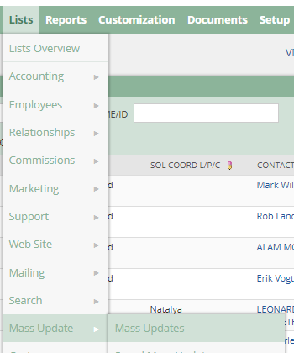
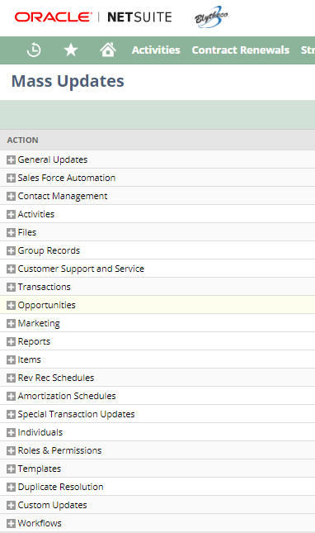
Click Custom Updates to see all script deployments for Mass Update scripts:

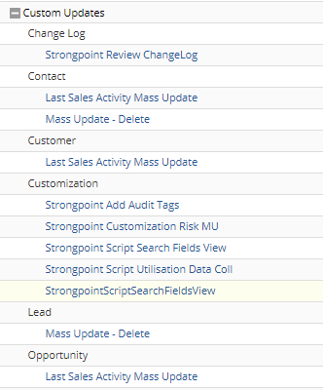
Click your Mass Update – Delete link to see:
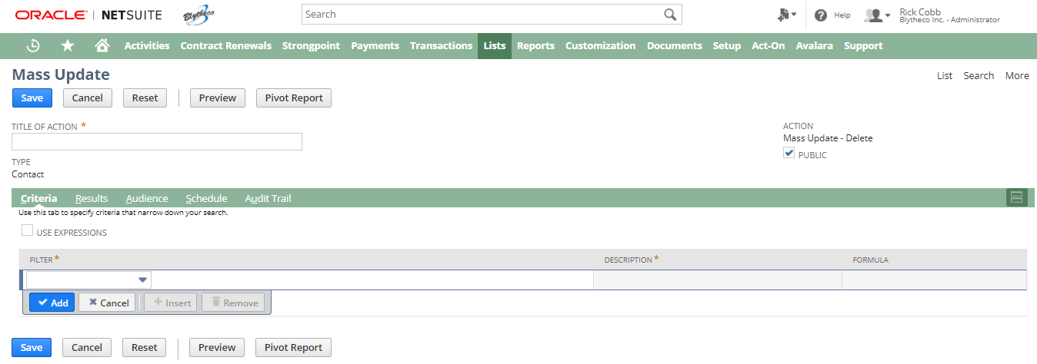

Build the saved search results to specify the records you’d like to delete:
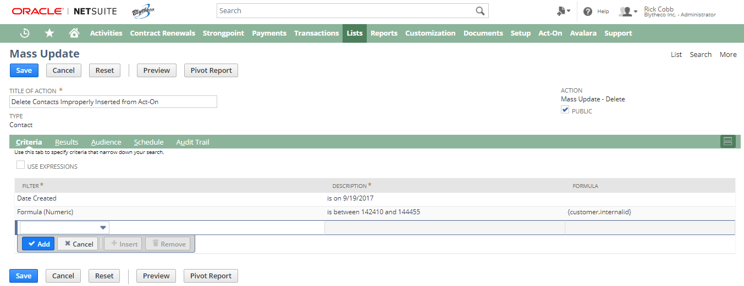
Click Preview to see all the records that will be deleted:
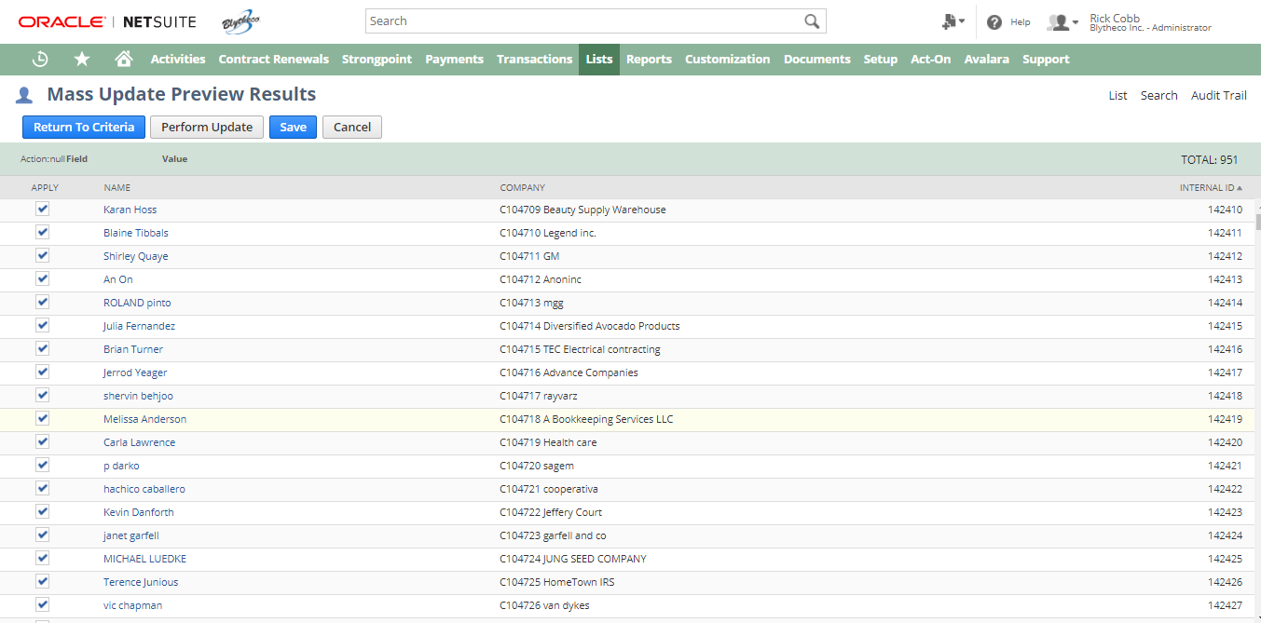
If you wish, you can click Perform Update, which will then delete all records in the saved search. You may also Save the current mass update without performing the update, and allow execution later:
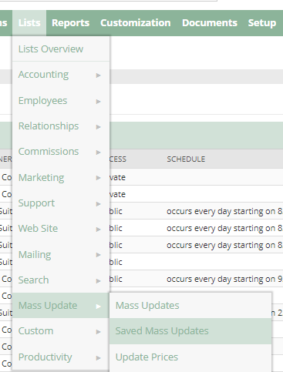
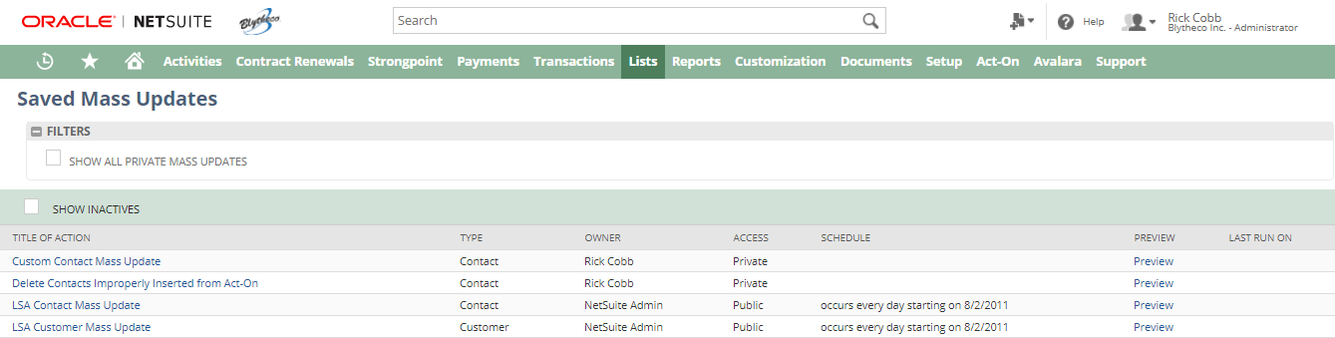
While the shell of the search exists, you’ll need to recreate the search criteria:
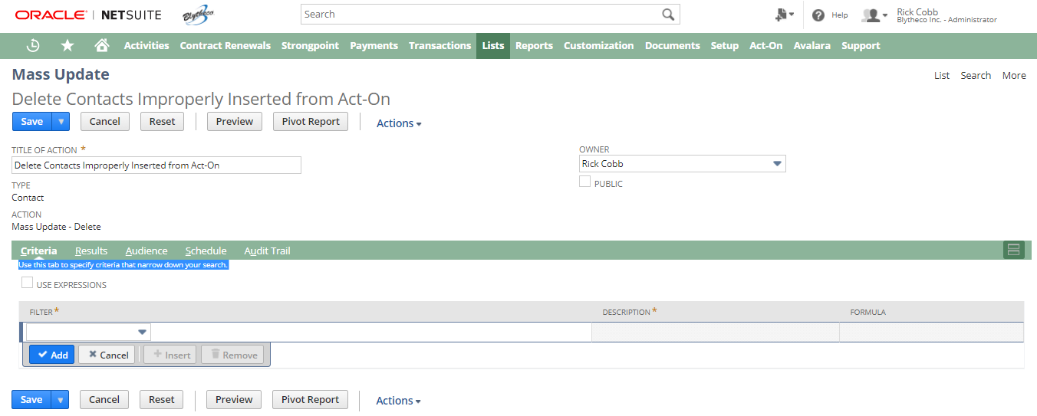

Let’s recreate and Preview:
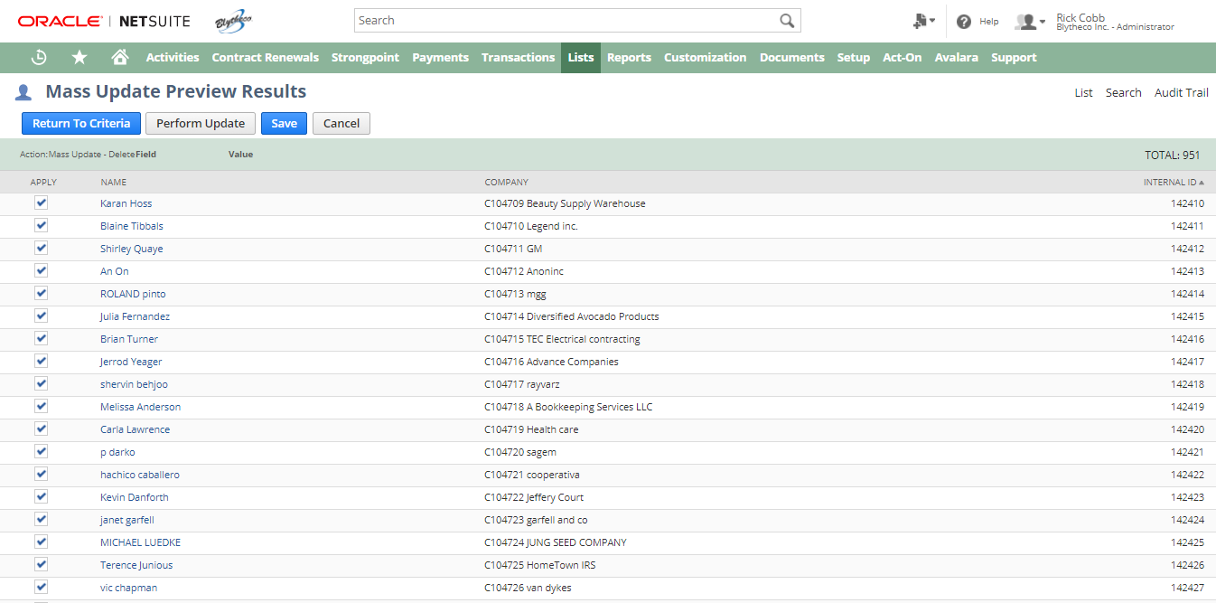
This time, let’s Perform Update on all records where the Apply checkbox is checked (which defaults to all records checked):
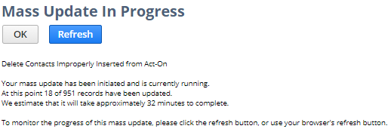
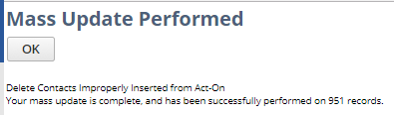
Let’s check the separate saved search on contacts:
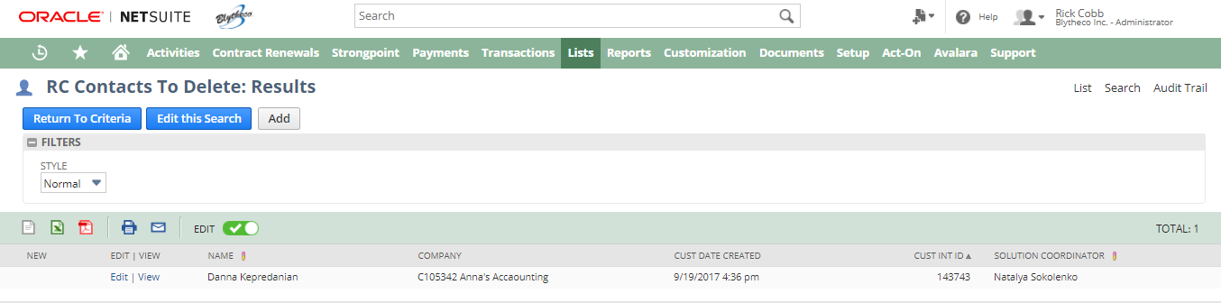
There is one record left that “should” have been deleted. Let’s try to delete the contact manually:
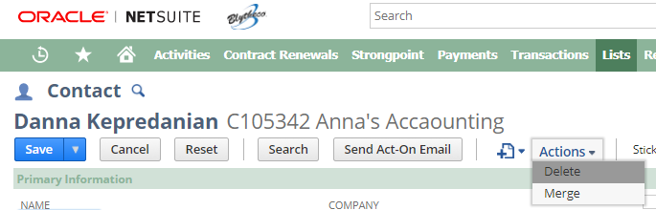
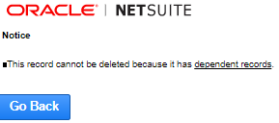
This implies that the Mass Update process will not delete records with dependent records, which is fine. We can handle any exceptions after the fact.

SQL Expressions and SuiteScript 1.0 Search Operators

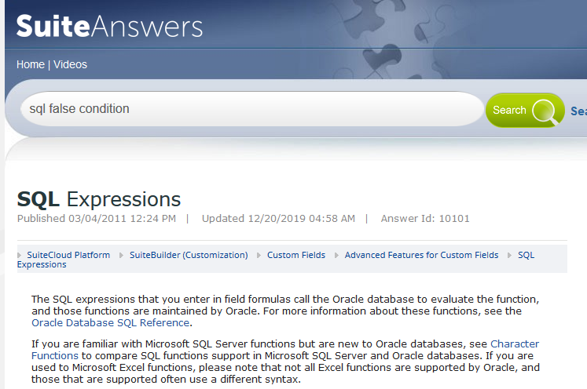

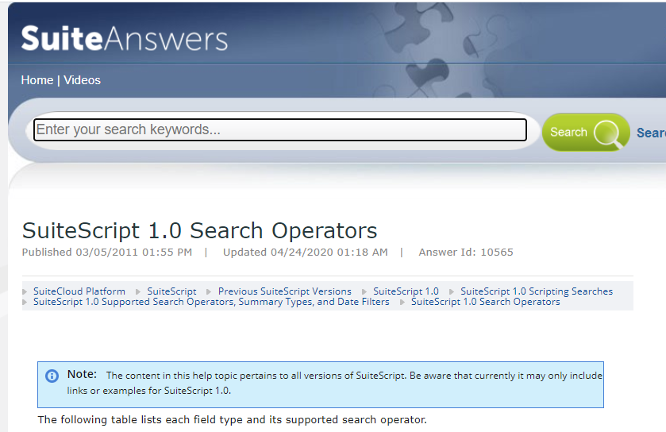

Search Items by Number and Description on SO Lines
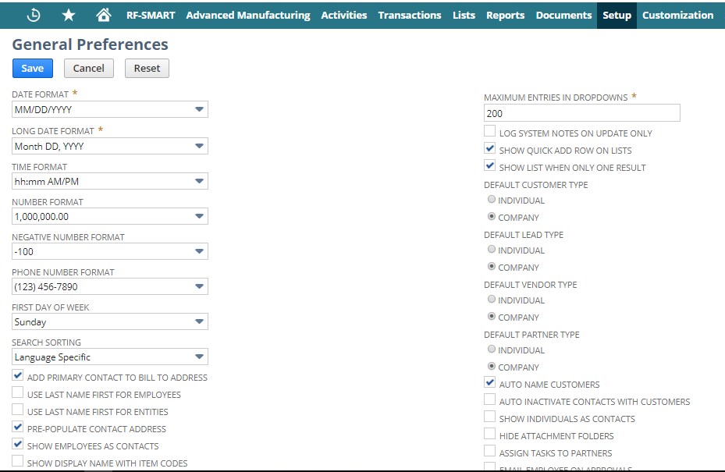
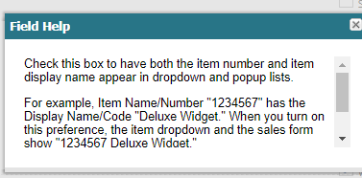

UPS Integration Configuration
UPS Integration is setup in the sandbox. For now I've set it to print to PDF, as I can't test the label printer remotely. That can be changed at any time. Here are the additional steps, I've attached screen shots for each step as well. :

Shipping Item Steps
- Shipping Items (methods) need to be updated to calculate real time rates (optional): List > Accounting > Shipping Items. Edit the shipping method you want to calculate based on real time rates. In the "Shipping Rate" tab set the radio button to "UPS Real-Time Rate" and choose the correct UPS method from the drop down. If you wish to mark up or down the rate you pass on to customers use the "discount rate" field. If you wanted to add 15% to your negotiated UPS rate, enter 1.15 in the discount field.
- 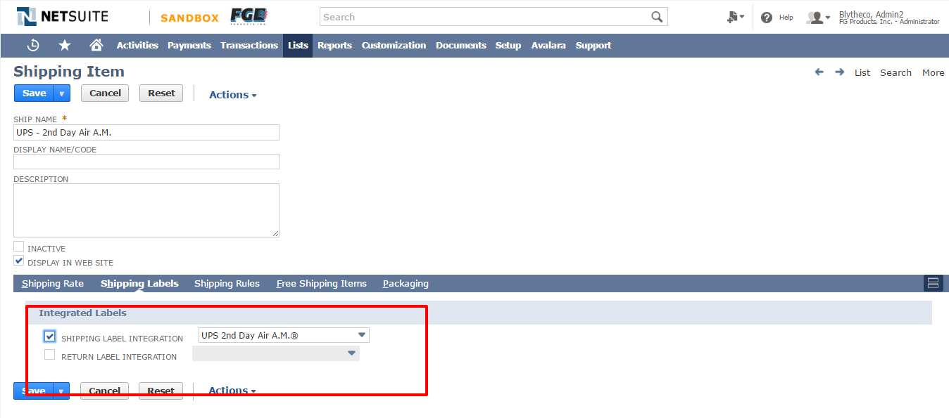
- 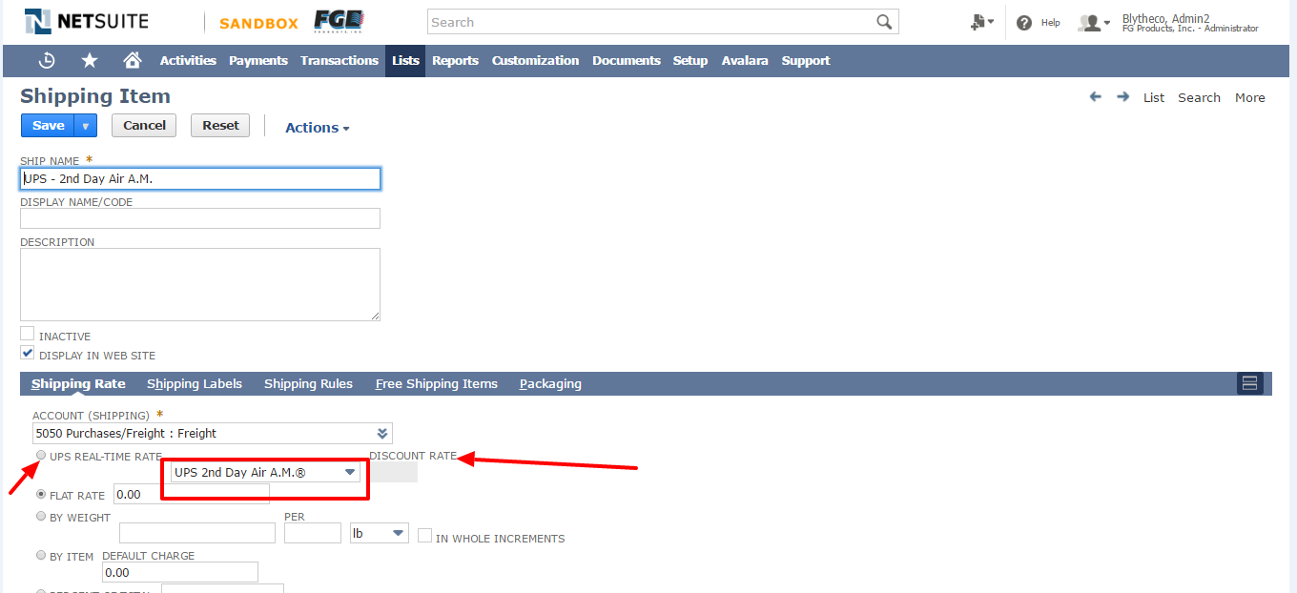
- Shipping Items (methods) need to be setup to print integrated labels: List > Accounting > Shipping Items. Edit the shipping method you want to print labels for. On the "Shipping Labels" tab, check the "Shipping Label Integration" box and select the appropriate UPS rate in the drop down box.

3rd Party Shipping
- On the Customer record, there are 4 fields on the customer record under the Financial tab. "3rd Party Billing Account Number", "3rd Party Billing Zip", "3rd Party Billing Country", & "3rd Party Billing Carrier". If these values are setup, UPS fulfillments will default to billing 3rd party, and no additional user intervention is required.
- 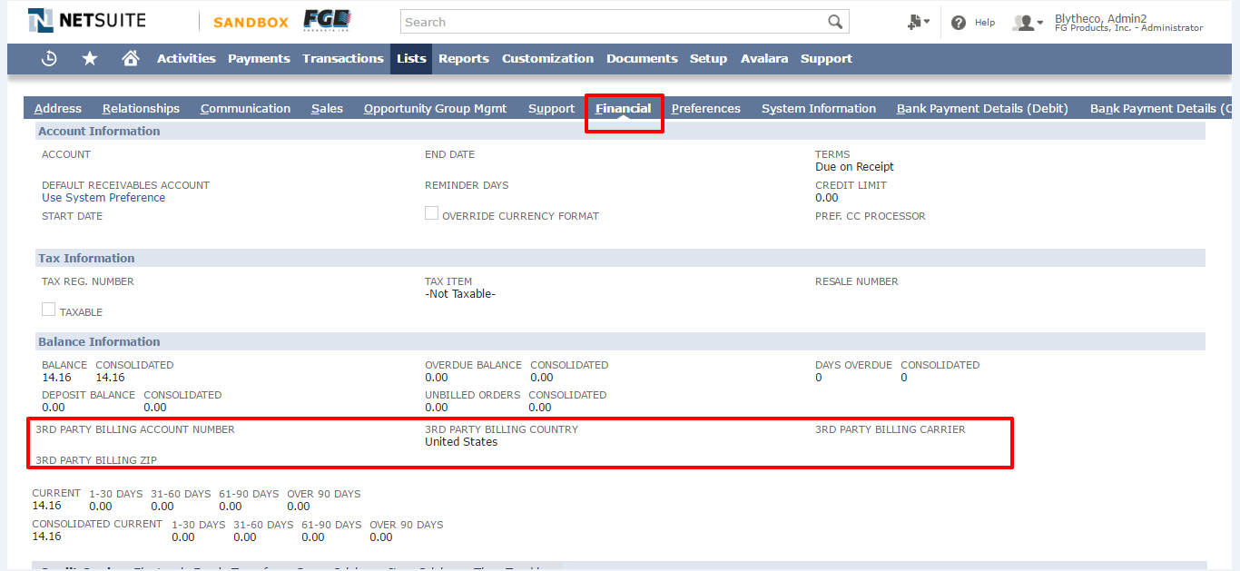
- On the Item Fulfillment the same fields appear on the "Carrier" tab. Note: The carrier tab only shows when you are using an integrated shipping method. Additionally there is a "3rd Party Billing Type" field with the following options: "None Selected", "Third Party Biling", "Consignee Billing". Choosing "None" will bill your UPS account. Choosing "Third Party" will bill the information setup on this page. Choosing "Consignee" will bill the account setup on the customer's page, regardless of what is on this page.
- 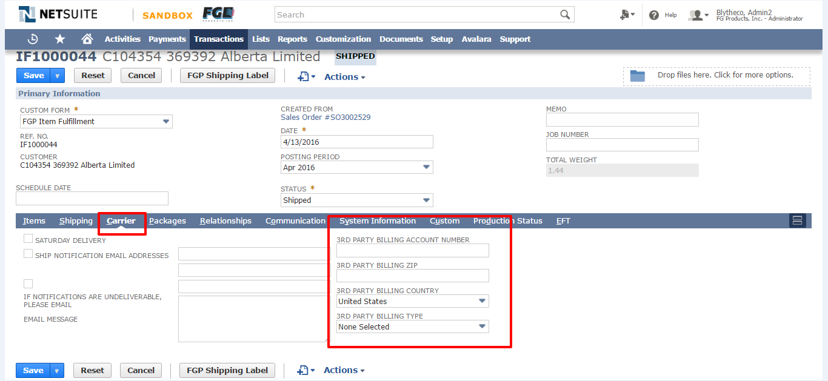

Tracking Numbers
- Tracking numbers can be entered on the "Packages" tab. For integrated shipments, click on the package at the bottom of the screen, and then enter the tracking number in the "Package Tracking Number" that appears above. Note: Normally you should not need to manually enter a tracking number for an integrated shipment. This should be populated automatically.
- 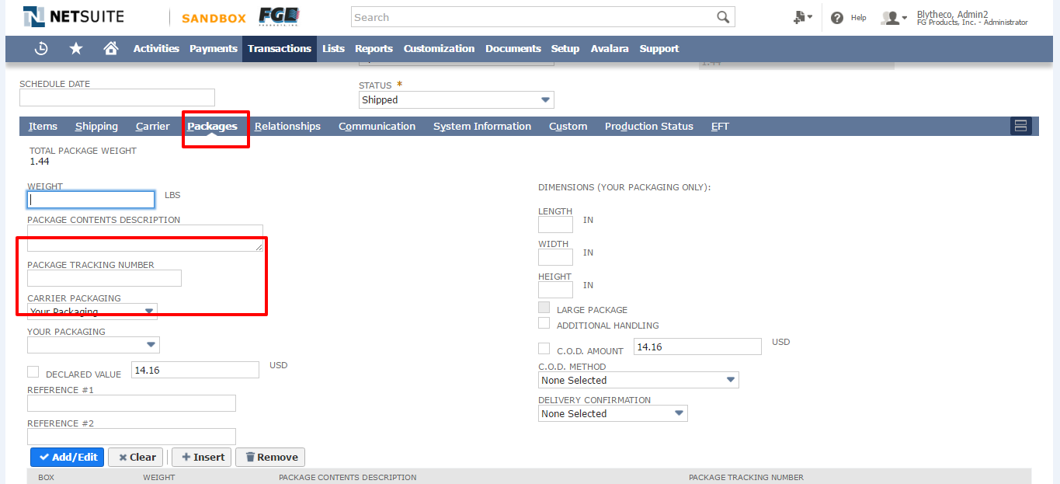
- For non-integrated shipping methods, each package has a line, and you can simply click on the line and enter tracking into in the "Package Tracking Number" column.
- 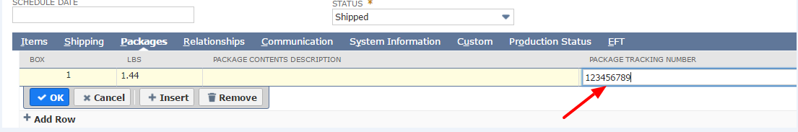

Changing email address for test drive account:
Support Case #: 2462843.
Hello Rick,
Could you, please, try to use this link?
https://system.na1.netsuite.com/app/center/validatekey.nl?key=43htUY5r2_05oU4-5_3&compid=TSTDRV1514451

Or at least, use its format as a template to adjust it with the data from the received wrong one = key values + test drive No.

Kind regards,
Lubo

